MONGO

# Installing MongoDB as a Service.

Go to the following web page: <https://www.mongodb.com/download-center/community> and download the MongoDB installer.

Open up the installer and continue as we will show you here below:

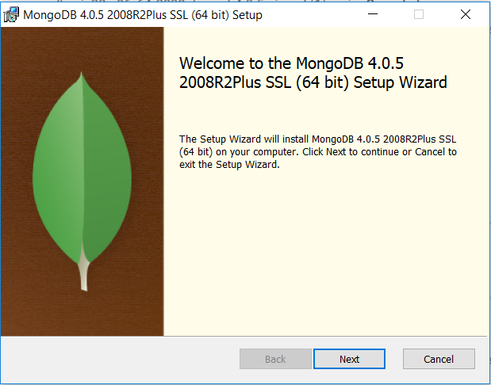

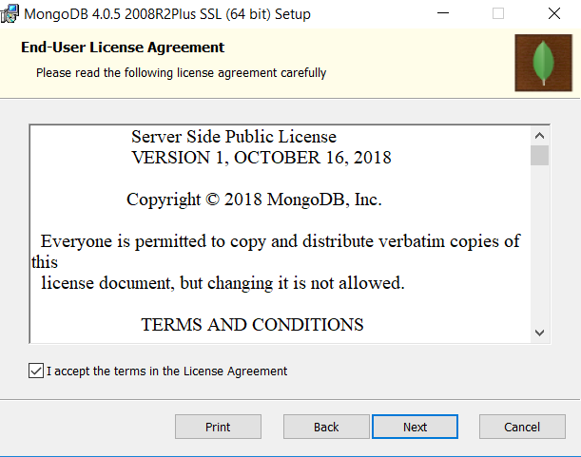

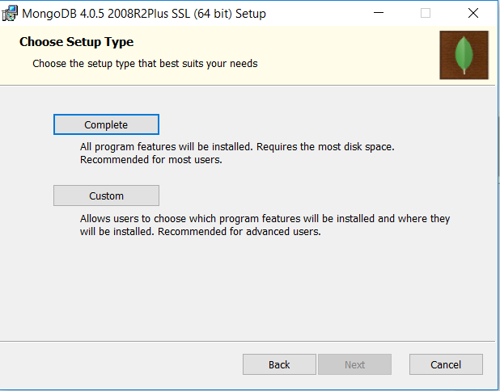

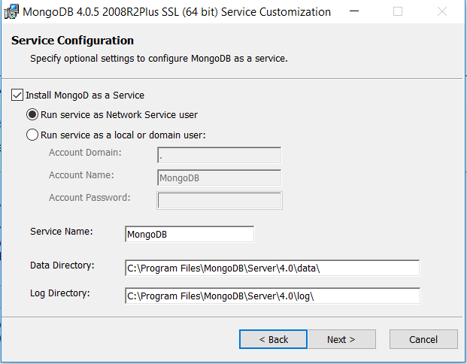

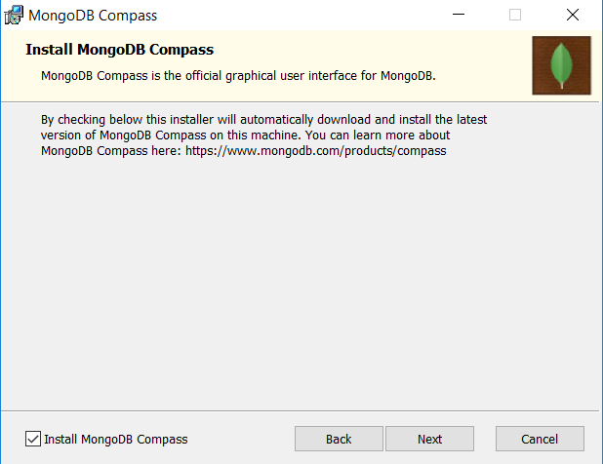

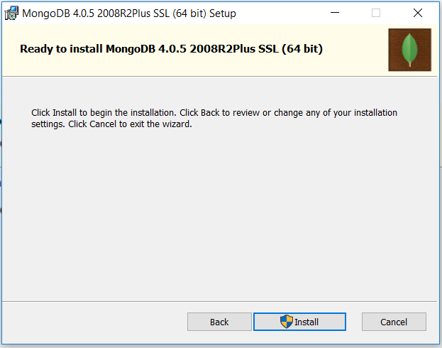

when the installer has finished clic on Finish button.

Open up the command prompt then typing the following path: C:\Program Files\MongoDB\Server\4.0\bin, as you can see in the below pic

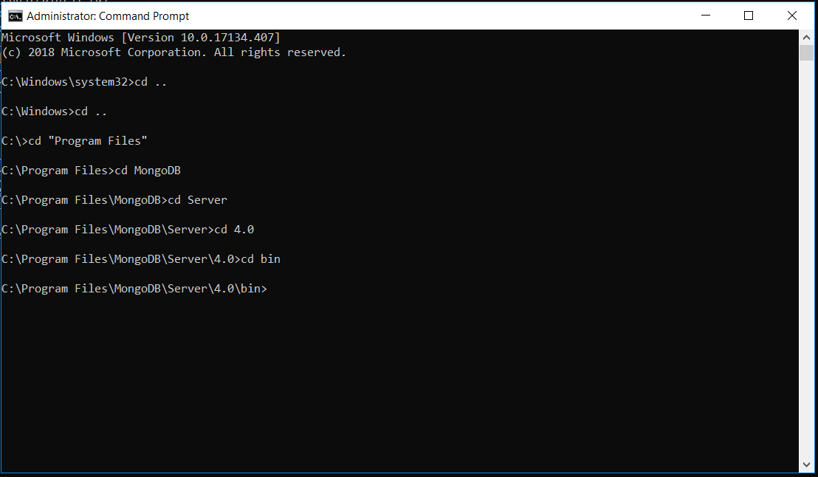

then you have to type the following command: mongod --dbpath C:\ContextualProjects\Mongo but before, you must create the folders

ContextualProjects and Mongo.

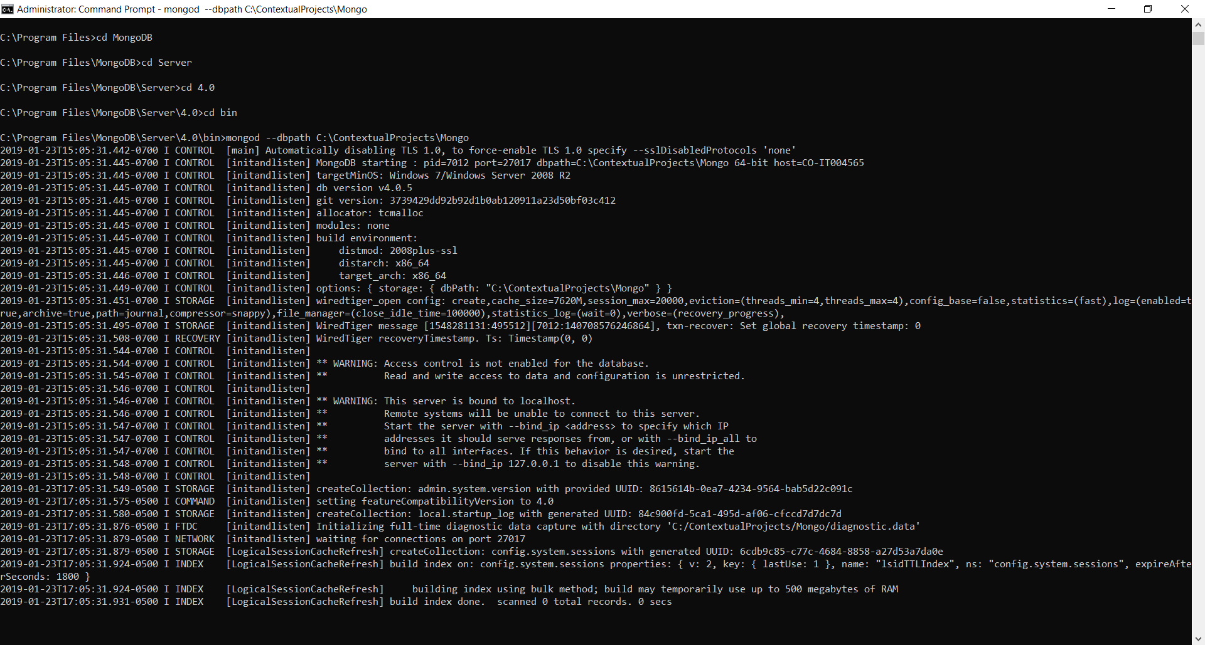

Right now, you can see waiting for connections on port 27017, this is the default port in MongoDB.

Install Robo 3T as MongoDB Client.

Go to the following website: <https://robomongo.org/download> and download Robo 3T, and run the Robo 3T installer.

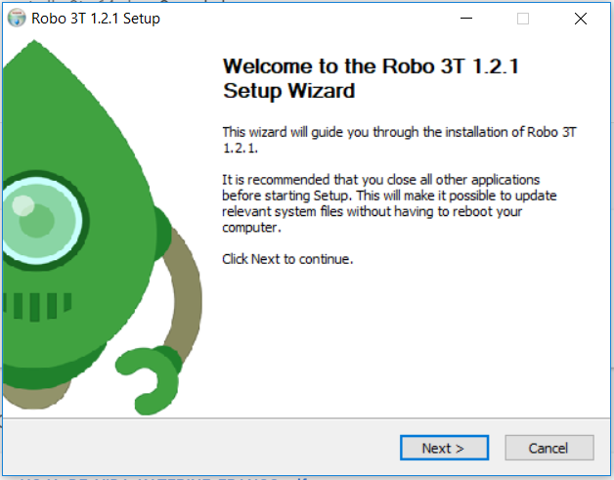

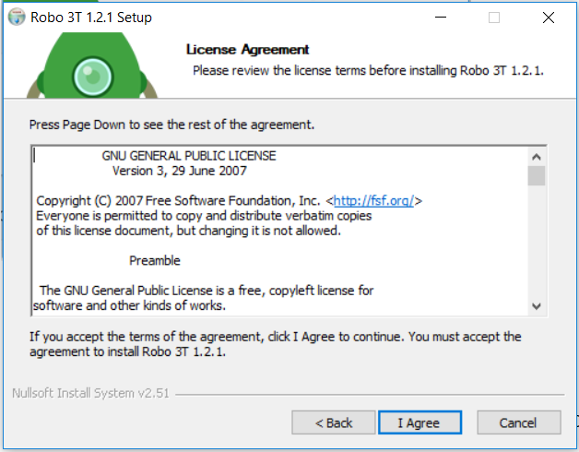

You can leave the default path as you can see in the below pic

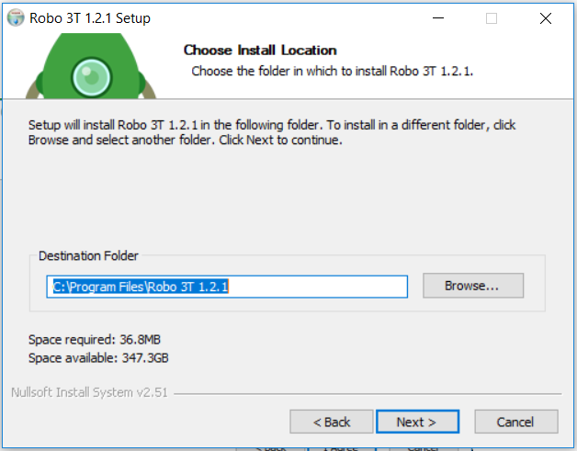

Click on install

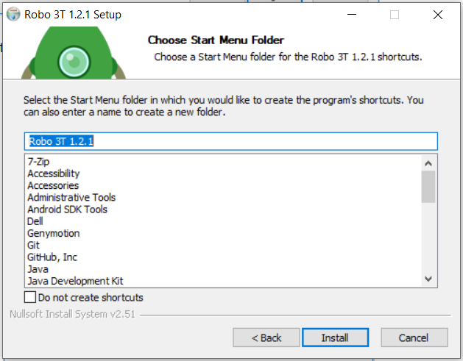

Finally click on finish

You can see the Robo 3T client open up.

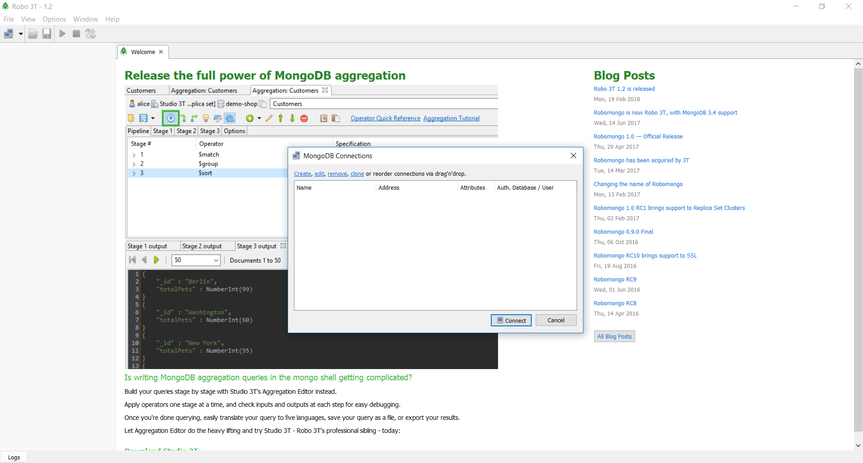

On MongoDB Connections popup we are not going to see a record.

Now you should click on create

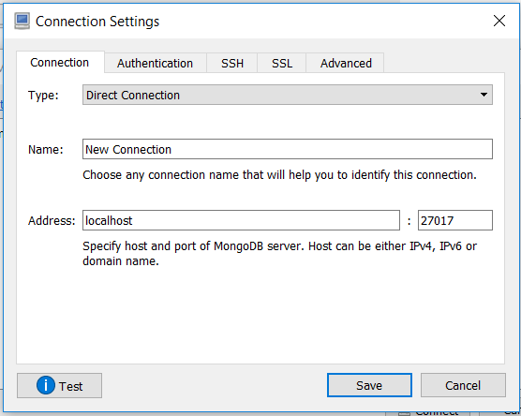

In the Connection Settings fields on Name you must add a new name for example: TestConnection on Address by default, then Click on save.

Now we are going to see this:

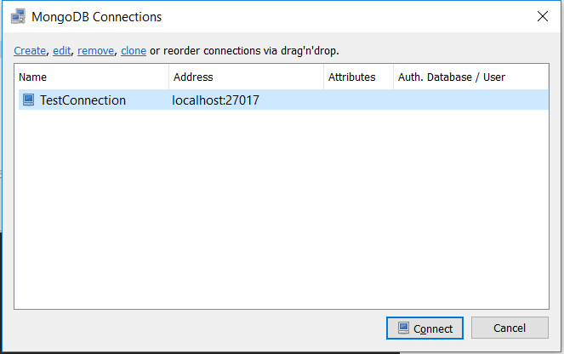

and click on Connect.

Now we are going to see all databases better than console view.

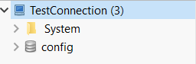

Note: In order to connect Robo 3T client with MongoDB service, you always have to execute the following command mongod --dbpath C:\ContextualProjects\Mongo at the root of mongo installation and then run Robo 3T Client.

# Creating Asp .net Core with MongoDB.

We are going to create a new .net Core Project then we are going to add MongoDB.Driver package.

On the root of the project we are going to create two folders, the first one will be called Data and inside of the Data folder will be called Entities.